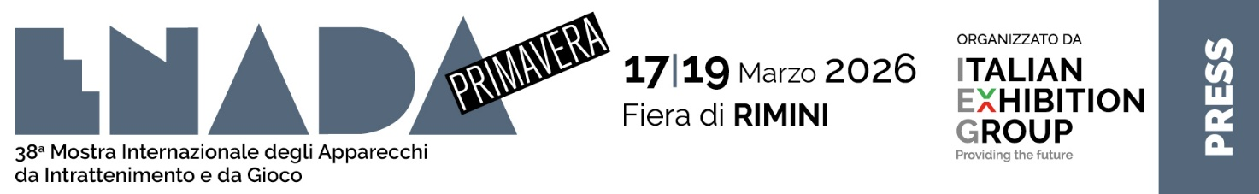
press release

ENADA PRIMAVERA OPENS TOMORROW: AT RIMINI EXPO CENTRE, THE GAMING WORLD BETWEEN BUSINESS, CONFERENCES AND competitive pinball

- The ribbon cutting ceremony at 12 noon will inaugurate the 38th edition of IEG’s gaming and amusement industry event
- Professional operators will find over 100 brands at the show and a conference programme centred on the sector’s latest innovations and key issues

Rimini, 16th March 2026 – The 38th edition of Enada Primavera, Italian Exhibition Group’s (IEG) event specifically for the gaming and amusement industry and promoted by SAPAR (National Association of State Gaming Services), will be opening its doors tomorrow at Rimini Expo Centre until Friday 19th.

The opening event is scheduled for 12 noon on the Vision Arena stage (Expo Hall C3) with speeches from Maurizio Ermeti, president of Italian Exhibition Group; Sergio D'Angelo, president of SAPAR, National Association of Services for Amusement and Recreational Public Machines; Francesco Bragagni, Rimini Municipal councillor for the development of policies for human resources, civic services, toponymy, legality and relations; Andrea de Bertoldi, secretary of the Chamber of Deputies’ VI finance and treasury commission as well as the commission of inquiry into illegal gambling.

For three days, the international network of gaming devices and systems will be gathering in Rimini Expo Centre’s halls to take stock of an industry in continuous technological and regulatory evolution thanks to an extensive conference programme focused on professional development and over 100 brands in attendance. A complete ecosystem where operators, suppliers and decision makers will be able to discuss the latest innovations and trends that are transforming the market.

For the 2026 edition, Enada Primavera will once again bring together the three sectors that drive the evolution of the gaming and entertainment world under one roof: land based gaming, online gaming - which this year acquires a new impetus within the event - and the world of amusement, which ranges from arcade games, such as billiards, pinball and bowling, to the more modern virtual reality and laser game solutions, as well as technologies for recreational facilities such as parks and entertainment centres.

THE ENADA PRIMAVERA 2026 AGENDA

For the entire duration of the show, the Vision Arena will be hosting a series of talks and meetings on the sector’s most current topics, providing a space for discussion between operators and experts.
Scheduled for 2.30 pm on the first day, tomorrow 17th March, the conference organised by IGE Magazine and entitled “Physical network and online channel: the reorganization of retail between Points of Sale for Recharges (PVRs), Awprs and new services” will feature an analysis of the public gaming situation in Italy and the evolution of the relationship between the physical and digital network. That will be followed at 4 pm with a talk on the development prospects of the entertainment sector entitled “Pure entertainment and the need to innovate: paragraph 7 towards the future”, organised by SAPAR.
In the following days, Enada Primavera’s conference program will address other key issues in the sector: from responsible gaming as a lever for consumer prevention and protection to the role of companies in the management and reorganisation of physical gaming, from digital payments to the ongoing transformation of the iGaming sector.

The 5th edition of the JJP Pinball Fest Enada by Luxury Games tournament, organised in collaboration with IFPA Italia, will also be held during the days of the event. With an international scope and valid for the WPPR ranking, the pinball sports tournament will welcome players of all levels, from beginners to professionals, offering a moment of competition and entertainment for enthusiasts and the public.

ABOUT ENADA 2026
Dates: 17-19 March 2026; organisation: Italian Exhibition Group S.p.A. in collaboration with SAPAR; edition: 38th; frequency: annual; info: https://www.enada.it/

PRESS CONTACT ITALIAN EXHIBITION GROUP
head of media relation & corporate communication: Elisabetta Vitali; press office manager: Marco Forcellini, Pier Francesco Bellini; international press office coordinator: Silvia Giorgi; press office coordinator: Luca Paganin; press office specialist: Nicoletta Evangelisti, Mirko Malgieri: media@iegexpo.it

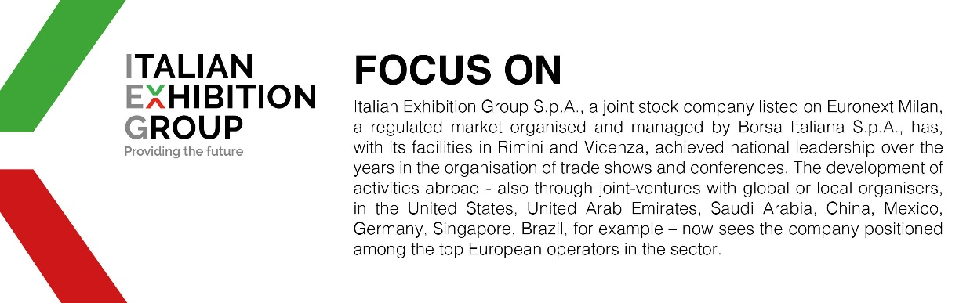

This press release contains forecast elements and estimates that reflect the management´s current opinions (´forward-looking statements´), particularly regarding future management performance, realization of investments, cash flow trends and the evolution of the financial structure. For their very nature, forward-looking statements have a component of risk and uncertainty, as they depend on the occurrence of future events. The effective results may differ (even significantly) from those announced, due to numerous factors, including, only by way of example: food service market and tourist flow trends in Italy, gold and jewellery market trends, green economy market trends; the evolution of raw material prices; general macroeconomic conditions; geopolitical factors and evolutions in the legislative framework. Moreover, the information contained in this release, does not claim to be complete, and has not been verified by independent third parties. Forecasts, estimates and objectives contained herein are based on the information available to the Company as at the date of this release.

